Book Review Conventional Outline
Create a 1-2-page book review of The Miracle Worker. I will be looking for a thorough analysis of the content, themes, and characters within the book.

Below is an outline of how you can structure your review:
Paragraphs should have proper structure (introductory sentence, key ideas, and concluding sentence). Please keep in mind transitions between paragraphs, spelling/ grammar, and sentence structures. Review the rubric to see how you will be graded.

- Introductory Paragraph,
  - Title of the book and the name of the author
  - Provide some background to enable the readers to place the book into context.
  - Your slant: thesis indicating your evaluation of the novel. Identify how the novel demonstrates a specific theme and how this makes it a valuable read, e.g., The Outsiders demonstrates how socio-economic status determines a person’s worth to society, a phenomenon that continues to exist in contemporary society.
- Possible theme: The importance of relationships in the lives of the main characters.

- Paragraph Two:
  - Introduce the setting—how it compliments or informs the theme
  - Main character(s)—how the choice of gender, age, socio-economic status, intelligence, etc. informs the theme you have identified in your thesis.
  - Conflict—explain how the conflict (against society/environment/etc.)
  - Other literary features that inform the theme thesis (foreshadowing, metaphors, etc.)

- Paragraph Three:
  - Brief overview of the ideas presented in the novel
  - You can provide some plot that informs the theme thesis

- Paragraph Four:
  - Critique of the book, identifying its success in demonstrating its theme.
  - Identify any weaknesses in the novel
  - In your opinion, is this story a good story? Why or why not?
  - Use quotations from the text to support your responses.

- Concluding paragraph
  - Final (summative) evaluation
  - Your recommendation or non-recommendation and explain why.

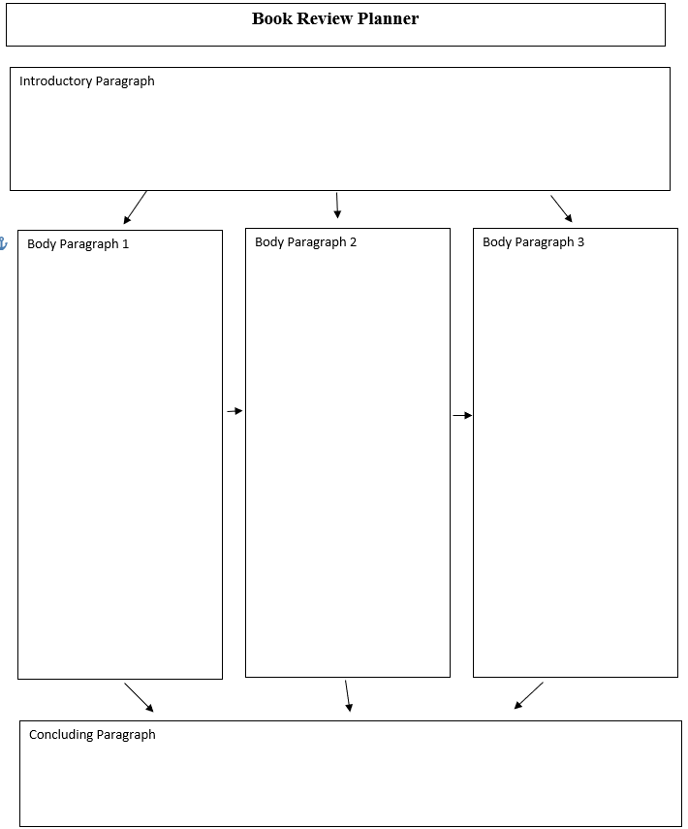
 |  | Established 4 | Progressing 3 | Developing 2 | Beginning 1
Message/ Meaning | Thoughtful explanations and references to texts | You explicitly and thoroughly relate your explanations about multiple aspects of the text to the text and draw relationships to other texts and experiences. | You effectively give thoughtful explanations, relating your ideas to the text. | With help you give basic explanations, somewhat relating your ideas to the text. Think about what you are being asked to explain. How can you support your ideas more fully? | You are having trouble giving explanations and relating your ideas to the text. What do you need to explain? How can the text help you with your ideas?
 | Opinions that have scope (strengths and weaknesses) | You succinctly and insightfully express multiple opinions that address strengths and weaknesses of the text you are reviewing. You support your opinions with thorough and insightful evidence. | You express opinions that address strengths and weaknesses of the text you are reviewing and provide support for your ideas. | With help you express some opinions that address some strengths and weaknesses of the text you are reviewing. Dig more deeply into the text. Make connections and think about how it makes you think and feel. | You are having trouble expressing opinions that address strengths and weaknesses of the text you are reviewing. How did the text make you feel? How did it address your purpose for reading it? What was strong? What wasn’t?
 | Recognizes theme | You succinctly and intuitively recognize and explain connections between the details of the text and its theme and support your ideas with strong evidence. | You independently recognize and explain connections between the details of the text and its theme. | With help you recognize and explain connections between some of the details of the text and its theme. Think about the author’s purpose and how it impacted the text you are reviewing. | With much help you recognize and explain basic connections between some details of the text and its theme. What do we mean by theme? How do you recognize a theme?
 | Identifies relevance of literary techniques (e.g. setting, characters, point of view, basic conflicts, plot development and use of literary elements) | You succinctly and intuitively recognize and explain the relevance of literary techniques to the overall effectiveness of the text. You are able to analyze the relationship between multiple techniques and how they impact the overall message. | You independently recognize and explain the relevance of literary techniques to the overall effectiveness of the text. | With help you mostly recognize and explain the relevance of some literary techniques to the overall effectiveness of the text. Explore more techniques. How do they affect the effectiveness of the text? | You are having trouble recognizing and explaining the relevance of some literary techniques to the overall effectiveness of the text. What are the techniques in a text? How do they affect a text? How can you share your ideas about this?

Book Review – Name _________________

Organization and Coherence | Details | Your composition demonstrates a deep understanding of topic and this emerges through engaging and comprehensive details about the place and time as it relates to your intended purpose. | Your composition demonstrates a clear understanding of the purpose and contains relevant details to support this purpose. You have an accurate representation of multiple aspects of your topic. | Your composition demonstrates a basic or uneven understanding of the topic. You needed support fleshing out details. What details could make your essay even stronger? Where can you go for additional information? | You are having trouble showing a clear understanding of your intended topic. Who is the person you are focusing on? What details are important? When did it take place? Where? What events are essential? Where can you go to find this information? How can you make sure your information is accurate?
 | Organization | Your text reflects careful and considered planning. All ideas are effectively sequenced with strong transitions and a powerful beginning and ending. Your essay offers insight for the reader about your topic. | Your text is organized clearly. You have logical sequencing, appropriate transitions and a considered beginning and ending. | Your text shows some evidence of planning. You needed help with organization and development of your ideas. Reference / create a graphic organizer or flow chart to increase the impact of your organization. Consider more unique transitions and ways to really hook the reader. | You are having trouble organizing your thoughts in writing. More time should be spent planning the structure and organization of the text before you even begin to write. How could you organize your essay? What are all the pieces you need? How can you show smooth movement from one idea to the next?
Language choice and conventions | Smooth transitions | Your topic flows eloquently from one part to the next enhancing the overall enjoyment of the writing. | Your representation smoothly flows from one part to the next. You effectively use transitional words and phrases. | With help you create basic transitions from one part of your writing to the next. How can you take some risks and try some new transitions? | You are having trouble creating a flow from one part of your writing to the next. Include your plans for transition in your map. Explore ways to move from one idea to the next.
 | Language cues and conventions | Your syntax is varied and polished and your word choices show style and efficiency. Any exceptions to standard usage are used for stylistic effect. Your text adheres to accepted standards of spelling, punctuation, and capitalization. Any errors are a result of risk taking. | Your syntax is effective, with some variety in length or structure. Your common sentence constructions are correct. The words you use to describe are clear but somewhat generalized. Your spelling, punctuation, and capitalization are generally correct. Your ideas are clear despite any mechanical errors. | Any uncomplicated sentence structures are usually clear, but your attempts at more complicated structures result in awkwardness and/or obscured meaning. The word choice you used to describe is sometime vague or overused. You needed some help with aspects of syntax and mechanics. Where can you go for help with this? How can you expand on your word choices? | You are having trouble with language cues and conventions. Your sentences are incomplete, run-on, or simple in structure. What tools do you have to improve word choice? What will help with creating effective sentence structure? Where can you go for help with mechanics?

