Independent Novel Study

Part One: Reading Journal
Your task is to keep a reading log and to complete three reading responses. Each reading response must be one paragraph in length. Complete one reading response for the early chapters of your novel, one for the middle chapters and one for the final chapters.
  - Reading Response #1
Answer one of the following questions:
- What is the time and place of the book. What evidence in the book tells you this?
- Name and describe the main character of the book.
- Find one specific idea, event, or behavior in the book that relates to real life. Explain.
  - Reading Response #2
Answer one of the following questions:
- What is the general feeling or mood of the book? Give specific examples of how the author creates that feeling or mood.
- Choose a sentence or phrase that attracts you. Explain why you chose I, its value in the book and its value to you.
  - Reading Response #3
Answer one of the following questions:
- What is the climax of the novel? What major conflict leads up to it and what is its resolution afterward?
- What did you learn from this novel?

Part Two: Story Element
Your task is to complete an activity for each Story Element (character, setting, plot). Choose one activity from each section.
  - Character: After reading your novel, identify the protagonist(s) and antagonist(s) within the story. Remember, protagonists and antagonists are not necessarily people.
a) Write a diary entry for one character. Each diary entry should be one paragraph in length and should draw on events from the story.
b) Create a “Wanted” poster for a character in the novel. Provide as many details as possible from the novel.
c) Write an interview with a major character in the novel. The interview should consist of 8 questions and each answer should be detailed and in complete sentences.
  - Setting: Examine the setting of the novel. Select a particular scene to represent. Be sure to consider the location, time period, and atmosphere of the setting.
a) Sketch a scene in the book depicting a part of the plot. I am marking for detail, accuracy, and effort, not drawing talent! Explain your illustration and why you chose to draw this scene in complete sentences.
b) Draw a colour map of where a major part of the story takes place. Label the major landmarks or points of interest. I am marking for detail, accuracy, and effort, not drawing talent!

  - Plot: Consider the “shape” of the story as it moves from an introduction, through a series of related incidents building to a climax, and coming to a conclusion.
a) Create a comic book that illustrates the major events of the novel. Your comic book should contain text so that somebody who has never read your novel will understand what happened in the book based on your comic. The templates for your comic book are posted on the class website on the “English” page.
b) Use the template below to complete a plot diagram for your novel.
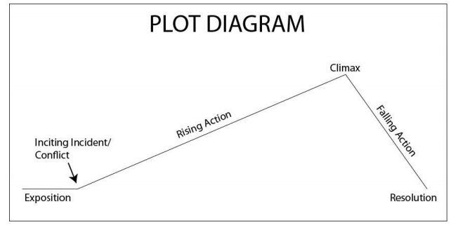

Part Three: Book Talk

Purpose: For your Book Talk, you will give one 3-5 minute presentation on the book you’ve read over the semester. The purpose of a book talk is to convince the listener to read the book you are recommending. This book talk is essentially a persuasive speech to convince the listener that they should read a specific book.

A book talk is very similar to a trailer for a film, which shows you just enough information to convince you that you should watch the movie. The book talk will cover some elements of the novel, but you should focus much of your time on the plot, themes and conflict in the novel. NO SPOILERS!!! Your presentation must include a visual aid, such as an illustration or original book cover, poster, power-point, or google presentation. If you are super tech-y, you might have an even better idea.

Your book talk should include:

- An introduction stating the title of the book, author, and genre. Your introduction should be interesting, compelling, designed to capture our interest – just as the introduction of an essay does.
- A brief, but detailed summary of the book, which does NOT give away the ending or other important surprise/suspense elements if your book has them. Give us a sense of what the book is about, but do not ruin it for us.
- A direct statement of your opinion of the book, along with at least two supportive reasons for your opinion.
An intelligent description of the author’s style or a key aspect of his/her style (such as use of symbol, dialect, etc.). You will select a short passage to read that is a good example of the stylistic element(s) you plan to discuss, and then you will discuss those elements and their impact on the reader and the author’s purpose. This should take 1-2 minutes.

