Persuasive Essay- ELA 20
CC20.4f Write an essay of argument/persuasion

Essay topics
You will choose ONE essay topic.
- Experiences of youth and childhood provide a foundation for life. /Children who aren’t disciplined for bad behaviour are learning that they can be bullies or jerks in their adult lives.
- Experiences of youth and childhood affect our development – mentally, physically, emotionally, and spiritually. Children who are physically abused or bullied often grow up to be abusive or bullies. Children who are abused will often have self-esteem issues.
- When children are encouraged to develop their sense of play, sense of wonder, imagination, and discovery it contributes to their development as healthy children and adults. Schools are so overly structured that children don’t get enough time to play. Children growing up in the 21st century are so consumed with technology that they do not benefit from unstructured play and imagination.
- The treatment and expectations of children and adolescents vary throughout the world and across cultures.
- First Nations children face issues, because of their race, that other Canadian children do not know.
- The roles of children and youth have changed over the years.
- Children and youth in the twenty-first century face different issues than those experienced by children in previous generations.

Final Product Expectations:
- Times New Roman or Calibri Font
- Size 12 Font, Double Spaced
- Cover Page
- Works Cited Page
- Hand written rough copy

Due Dates:
You will have January 8 and 10 to complete your research.
Your Rough Draft must be completed by the end of class on January 16
The good copy is due on January 21

Step One: Before I write
Strategies I will use as I prepare to write. Decide on:

- My Purpose-
- My Role-
- My Audience-
- My Form-
- My Topic-
- My Graphic Organizer: How will I plan and organize my ideas for writing? What will I use? Web, outline, etc.

Step Two- Writing Process: During Strategy
Drafting-The next step of the writing process is to create a rough draft of your Persuasive Essay:
Outline for Persuasive Essay
Paragraph #1 - Introductory Paragraph: The first paragraph of your essay introduces your subject. The introduction leads up to the thesis statement, which expresses the main idea you will develop in your essay.

A. Hook: a sentence that should introduce the topic and grab the reader’s attention.
____________________________________________________________________________________________________________________________________________________________
B. Summary of Researched Information: A few sentences explaining your topic in general terms that leads the reader gently to your thesis. Each sentence should become gradually more specific, until you reach your thesis.
__________________________________________________________________________________________________________________________________________________________________________________________________________________________________________
C. Thesis statement: states the main idea of your essay.
____________________________________________________________________________________________________________________________________________________________

Paragraph #2 -Body Paragraph: Support your thesis with facts, examples and details. Use the information you have gathered to support and develop your idea about your subject.

A. Big Idea (topic sentence/introductory sentence): ____________________________________________________________________________________________________________________________________________________________
B. Background Information: Provide support/proof from your research. This is where you include quotations/paraphrase from your sources. Be sure to cite these correctly when you insert them into your essay.
________________________________________________________________________________________________________________________________________________________________________________________________________________________________________________________________________________________________________________________
C. Concluding Sentence: Summarize what you’ve discussed in this paragraph in one sentence.
__________________________________________________________________________________________________________________________________________________________________________________________________________________________________________

Paragraph #3 -Body Paragraph: Support your thesis with facts, examples and details. Use the information you have gathered to support and develop your idea about your subject.
A. Big Idea (topic sentence / introductory sentence)

____________________________________________________________________________________________________________________________________________________________

B. Personal background: Provide support/proof from your inquiries. This is where you include quotations/paraphrase from your sources. Be sure to cite these correctly when you insert them into your essay.
__________________________________________________________________________________________________________________________________________________________________________________________________________________________________________
C. Concluding Sentence: Summarize what you’ve discussed in this paragraph in one sentence.
____________________________________________________________________________________________________________________________________________________________

Paragraph #4 -Body Paragraph: Support your thesis with facts, examples and details. Use the information you have gathered to support and develop your idea about your subject.

A. Big Idea (topic sentence/introductory sentence)
__________________________________________________________________________________________________________________________________________________________
B. What actions have occurred as a result? How much world attention has the subject caused/ received? What other individuals, organizations are promoting the cause?

Provide support/proof from your inquiries .This is where you include quotations/paraphrase from your sources. Be sure to cite these correctly when you insert them into your essay.

__________________________________________________________________________________________________________________________________________________________________________________________________________________________________________
C. Concluding Sentence: summarize what you’ve discussed in this paragraph in one sentence. ____________________________________________________________________________________________________________________________________________________________

Paragraph #5 - Concluding Paragraph

A. Big Idea (topic sentence/introductory sentence):
___________________________________________________________________________
Body sentence ideas: A broadening of the thesis statement—can be split from one sentence into many—and a BRIEF summary of supporting details. DO NOT include new ideas. Statements should lead to a generalized conclusion.
__________________________________________________________________________________________________________________________________________________________________________________________________________________________________________Clincher statement(a statement that goes beyond what you have said in your essay and makes a final impression on the reader; a clincher about lesson learned; or connection to contemporary issues or beliefs. Try to avoid clichés.)
__________________________________________________________________________________________________________________________________________________________________________________________________________________________________________

In Text Citation (MLA)
You have two choices that you can use to avoid plagiarism:
- Use a direct quotation.
- Use the author’s exact words in “quotation marks”
- Don’t make ANY changes
- Give the author’s name (Wilson 5)
That tells your teacher, “I did not write this part. These are someone else’s words.”

- Paraphrase
- Explain the main ideas of something you read
- Write completely in your own words
- Show that you understand the source
- Cite the source (Wilson 5)
How to paraphrase:
- Put the source away
- Write about what you read in your own words.
- Pretend you’re explaining to a friend.
- DON’T put anything in your paper that you don’t understand.

Citing Your Sources in Your Paper
- Author and page #:
(Martinez 5)
- For websites, sometimes you don’t have a page number:
(Martinez)
- Sometimes you don’t have an author either! Use the page title:
(“Pollution”)

Example of Paraphrasing: Americans throw away too much trash. For example, we created 245 million tons of trash in 2006 (Parks 7). Our trash includes things like paper and food scraps that could be recycled or composted instead.
Example of a direct quote: “In 2006, about 245 million tons of trash were produced in the United States” (Parks 7).

Works Cited Page
A page at the end of your paper listing each source you used.
Citing a Website:
You list your citation information in the following order:
- Author. (Sometime there is not an author listed)
- Title of source.
- Title of the container,
- Other contributors (names and roles),
- Version,
- Number,
- Publisher,
- Publication Date,
- Location of the source (such as URL or page range).
Example:
“Pluto.” Solar System Exploration. National Aeronautics and Space Administration, n.d. Web. 16 Oct. 2012. <http://solarsystem.nasa.gov/planets/
profile.cfm?Object=Pluto>.

Citing a Book:
Last, First M. Book Title. City of Publication: Publisher, Year Published. Print.

WHAT IS A TRANSITION?
In writing, a transition is a word or phrase that connects one idea to another. This connection can occur within a paragraph or between paragraphs. Transitions are used to show how sentences or paragraphs are related to each other and how they relate to the overall theme of the paper.
USING TRANSITIONS BETWEEN PARAGRAPHS
Transitions can be useful between paragraphs to connect two ideas. Effective transitions highlight the key information from one paragraph to the next and help to create a logic flow between ideas. These transitions do not always have to use transitional words or phrases; however, they can be useful. P1 represents the last sentence in paragraph one. P2 represents the first sentence of paragraph two.
Transition sentences should be the first sentence of a new paragraph that links two paragraphs together. Here are some examples:
Example:
P1: The author’s work includes many examples of symbolism.
P2: In the story, multiple themes are present.
Revision:
P1: The author’s work includes many examples of symbolism.
P2: In addition to the symbolism in the text, multiple themes are present.
Rationale: The transition helps to show how the two paragraphs are related and helps to show the reader the underlying similarities.
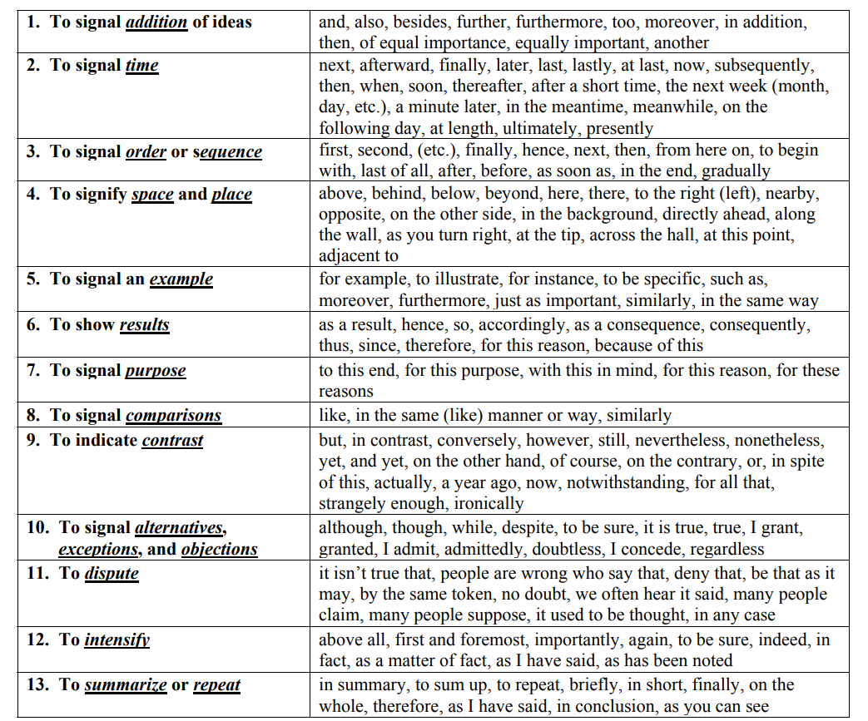
Transition Words/ Phrases

Introductory Paragraph (engage the reader’s interest and what your essay will be about):
Five Paragraph Essay Planner

Body Paragraph 3 (Supporting details and examples):

Body Paragraph 2 (Supporting details and examples):

Body Paragraph 1 (Supporting details and examples):
Concluding Paragraph (summarize, restate, and leave a parting thought):

